***Navigating the Coding Odyssey: A Journey of Passion, Learning, and Growth***

BY

MANISH SHASHIKANT JADHAV

2023301005

COMPS - B

Greetings, I'm Manish Shashikant Jadhav, a dedicated computer engineering student with a fervent passion for coding and technology. My journey into the world of programming began during my Post SSC vacation in 2020, where I discovered the endless possibilities of web development. Currently pursuing my B.Tech in Computer Engineering at Sardar Patel Institute of Technology, Mumbai, I am constantly exploring new technologies and expanding my skills in frontend and backend development. Join me on this blog as I share my experiences, insights, and projects, and delve into the exciting realm of coding, innovation, and personal growth.

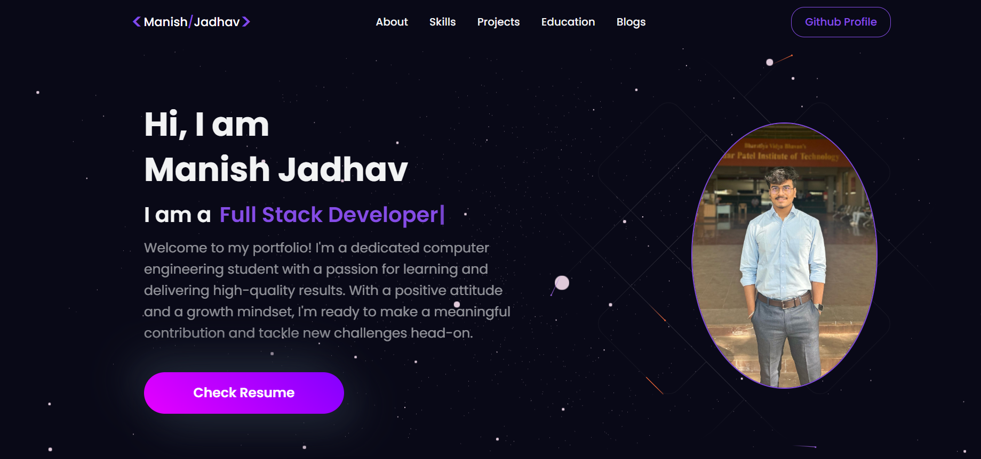

**Introduction and Motivation:**

Ever since I can remember, I've been fascinated by technology and its ability to shape the world around us. It was this fascination that led me to embark on my coding journey during my Post SSC vacation in 2020. I was drawn to the world of web development, with its endless possibilities and the opportunity to create something meaningful and impactful. Little did I know that this decision would set me on a path towards a rewarding career in computer engineering.

**Diploma in Information Technology**:

* Pursuing a Diploma in Information Technology from Dr. Babasaheb Ambedkar Technological University, Lonere, was a transformative experience.
* The curriculum was rigorous, covering a wide range of subjects from programming languages to database management.
* One of the key projects that influenced my learning was the development of IOPE Diaries which was my final year project. This project not only honed my skills in web development but also taught me valuable lessons in project management and teamwork.

**Mastery of Programming Languages:**

My journey in web development also involved mastering a multitude of programming languages. I became proficient in C, C++, Python, Java, and Perl, leveraging their unique features and functionalities in various projects. Additionally, I explored Android development using Java and XML, creating mobile applications with rich user interfaces and seamless functionalities.

**Web Development Skills:**

I delved deeper into frontend technologies, honing my skills in HTML, CSS, and JavaScript. I embraced frameworks like React JS and NextJS, which empowered me to build dynamic and responsive user interfaces. Additionally, I mastered Redux for state management and TypeScript for enhanced code scalability and maintainability.

In parallel, I ventured into backend development, utilizing Node JS and Express JS to build robust server-side applications. I gained proficiency in database management systems like MySQL, MongoDB, and Firebase, learning to design and implement efficient data storage and retrieval mechanisms. Furthermore, I explored big data technologies such as Hadoop and Oracle, broadening my understanding of data processing and analytics.

**Transition to B.Tech:**

Transitioning from my diploma to pursuing a B.Tech in Computer Engineering at SPIT, Mumbai, was both exciting and challenging. The academic rigor increased, and I was exposed to new concepts and technologies. However, the solid foundation I had built during my diploma helped me navigate through these challenges with confidence. The support and guidance of my professors and peers also played a crucial role in making this transition smooth.

**Current Projects and Learning:**

* Currently, I am focusing on honing my skills in frontend development, particularly in ReactJS and its ecosystem. I am also exploring the world of TypeScript and NextJS to enhance my frontend development capabilities.
* In terms of backend development, I am diving deeper into Node.js and Express.js, and exploring databases like Firebase and Hadoop.
* Additionally, I am learning about machine learning and its applications in Python, with a focus on libraries like NumPy, Pandas, and SciKit Learn.

**Impact of Projects:**

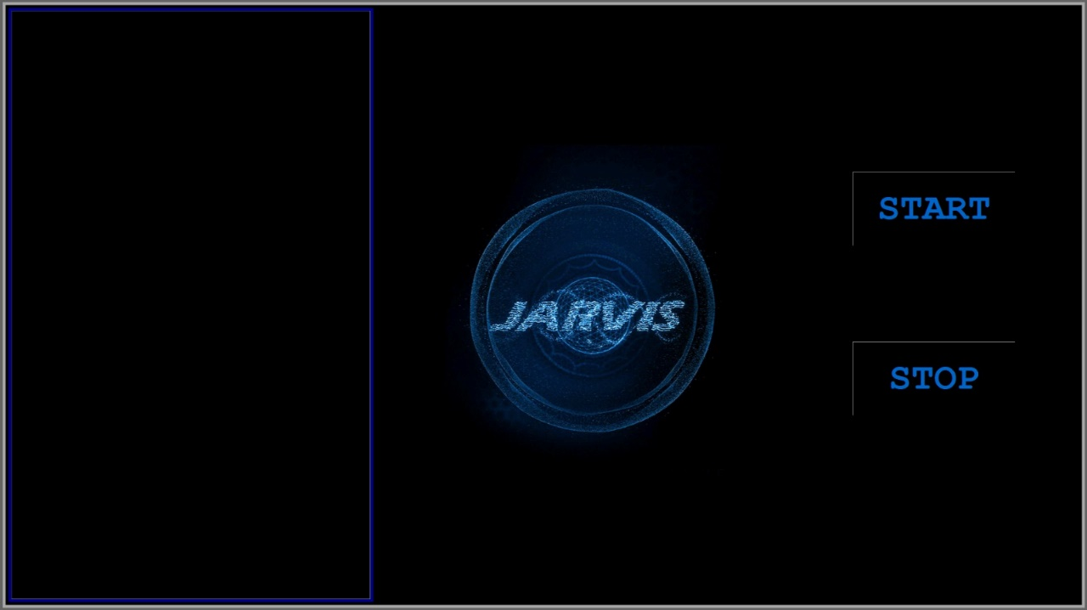The JARVIS project, undertaken as a Second Year Mini Project, has been transformative, significantly impacting my skills and approach to problem-solving. Integrating language processing algorithms for seamless communication, it enhanced my understanding of natural language processing (NLP). The project's focus on image processing, including a 'take a photo' option and a camera module, introduced me to computer vision, broadening my skills. Collaboration and teamwork were key, teaching me valuable lessons in effective communication and task delegation. Overall, the JARVIS project has not only expanded my technical expertise but also inspired me to explore new and innovative ways of solving complex problems.

**Learning Resources:**

Throughout my coding journey, I have relied on various learning resources to enhance my skills. Online platforms like Coursera, Udemy, and YouTube have been instrumental in providing me with in-depth knowledge and practical insights. Books like "Eloquent JavaScript" and "Node.js Design Patterns" have also been valuable resources that have helped me deepen my understanding of programming concepts.

**Community Engagement:**

I have actively engaged with the coding and tech community through participation in hackathons, meetups, and online forums. These experiences have exposed me to diverse perspectives and ideas, and have helped me expand my network and learn from others. One memorable experience was participating in a hackathon where I collaborated with a team to develop a prototype for a social networking platform.

**Professional Development**:

My coding journey has significantly contributed to my professional development. It has opened up opportunities for internships, freelance work, and other professional experiences that have allowed me to apply my coding skills in real-world scenarios. These experiences have not only enhanced my technical abilities but have also helped me develop crucial soft skills like communication and teamwork.

**Freelancing Experience:**

I have also gained valuable experience through freelancing, where I have worked on various web development projects for clients. This experience has not only allowed me to apply my skills in real-world scenarios but has also helped me develop crucial skills in communication, project management, and client relations.

**Contribution to Open-Source Projects:**

I am passionate about contributing to open-source projects, collaborating with like-minded developers to create impactful solutions. I believe that open-source collaboration not only enhances my skills but also allows me to give back to the community. I aim to actively participate in projects that align with my interests, such as enhancing security, improving performance, and promoting accessibility in web development.

**Switch to Cybersecurity and Ethical Hacking:**

* As I continue to explore different career paths, I am also considering transitioning to cybersecurity and ethical hacking.
* The rapidly evolving landscape of cybersecurity and the increasing importance of digital security have captured my interest, and I am eager to learn more about this field.
* I believe that my strong foundation in programming and web development will serve as a solid base for this transition, and I am excited about the potential opportunities that lie ahead in this dynamic and challenging field.

**Future Goals:**

In the future, I aspire to become a proficient full-stack developer, capable of building robust and scalable web applications. I also aim to contribute to open-source projects and collaborate with like-minded developers to create impactful solutions. Continuous learning and growth are at the core of my future goals, and I am committed to pushing the boundaries of my knowledge and skills in the field of web development and computer engineering. Additionally, I am keen to explore cybersecurity and ethical hacking, leveraging my skills to enhance security measures and protect digital assets.

**Challenges Overcome:**

One of the challenges I faced during my coding journey was balancing my academic responsibilities with my passion for coding. Managing my time effectively and prioritizing tasks helped me overcome this challenge. Another challenge was learning to navigate complex technical concepts, but with perseverance and dedication, I was able to overcome these obstacles.

**Reflections and Advice:**

* Looking back on my coding journey so far, I am grateful for the opportunities I've had to learn and grow.
* One piece of advice I would offer to others starting their coding journey is to never stop learning and exploring.
* The field of technology is constantly evolving, and staying curious and adaptable is key to success.

**Acknowledgments:**

I would like to express my heartfelt gratitude to my mentors, teachers, and peers who have supported and guided me throughout my coding journey. Their encouragement and insights have been invaluable, and I am truly grateful for their contributions to my growth and development.

**Conclusion:**

As I reflect on my coding journey and consider the path ahead, the prospect of transitioning to cybersecurity and ethical hacking fills me with excitement and determination. The challenges and innovations this field offers, along with the high demand for skilled professionals and the opportunity to contribute to security and society, make it a compelling choice for my future career. I am eager to embark on this new chapter, armed with the knowledge and skills I have acquired through my web development journey, and I am confident that this transition will open up a world of possibilities and opportunities for growth and learning.